

**Department of Computer Engineering**

**CMPE 208 - Network Architecture and Protocols**

**PROJECT REPORT**

**TeamViewer**

**Under Prof. Shai Silberman**

**Team:**

**Sphoorti Metri - 011425102**

**Ashwini Chilukuri - 011538254**

**Lakshmi Devi Palanivelu - 011814556**

**Abhilash Garimella - 011416067**

Table of Contents

1. Contribution of each member 3

2. Introduction 3

3. Setup 4

How we executed 5

4. Capture and Analysis 7

4.1. Initial Handshake 7

4.2. CMD_PING 8

4.4. CMD_DISCONNECT 9

4.6. CMD_MASTERRESPONSE 11

4.7. Keep Alive Server Connections 11

4.8. CMD_IDENTIFY 13

4.9. CMD_REQUESTKEEPALIVE 14

4.10. CMD_SESSIONID 14

4.11. CMD_ROUTERCMD 15

4.12. CMD_BUDDY 16

Status of TeamViewer 17

4.13. Complete Connection 17

4.14. Final Hand Shake – Logout 18

5. Troubleshoot 19

6. Security 21

6.1. Process: 21

6.2.1. Secure Remote Password (SRP) protocol 24

6.2.2. Password Authenticated Key Agreement 30

6.3. TeamSpy 30

6.4. Observations: 33

6.4.1. TLS packet capture and analysis 34

Client Hello 34

Client Key Exchange, Change Cipher Spec, Encrypted handshake message 36

Objective: 36

7. Test Cases 37

8. Findings 42

9. References 43

# **Contribution of each member**

All the team members worked together and contributed equally. Each of us majorly concentrated on the following

Topology and lab setup – Lakshmidevi & Ashwini Chilukuri

Wireshark captures and analysis – Sphoorti Metri & Ashwini Chilukuri

Security Analysis – Abhilash Garimella & Sphoorti Metri & Lakshmidevi

Documentation - Abhilash Garimella & Sphoorti Metri & Ashwini Chilukuri

# **Introduction**

TeamViewer is program that can be used for remote control (access remote host and control it), desktop sharing (sharing a desktop screen is a process where one host can look at what is happening in the other host he/ she is connected to), web conferences and meetings as well as file transfer.

Following is the procedure for establishing connection between two remote systems/ hosts:

1. Start TeamViewer on both the hosts.
2. As soon as the application gets launched, we can find ID and Password under the Allow Remote Access section.
3. To establish a connection, the local client needs the ID and password of the remote host. Once the user types in correct credential, he/ she get connected to the remote host.
4. Closing the application will close the connection between the local client and remote host.

The TeamViewer application binds to the port 5938 on the host machines.

# **Setup**

* Installed the latest version of Team Viewer (13.0 Beta) on two machines. If the Versions are not same on both the machines the connection will not get established.
* Master ID and Master server name will be given once the download is complete.

Example:

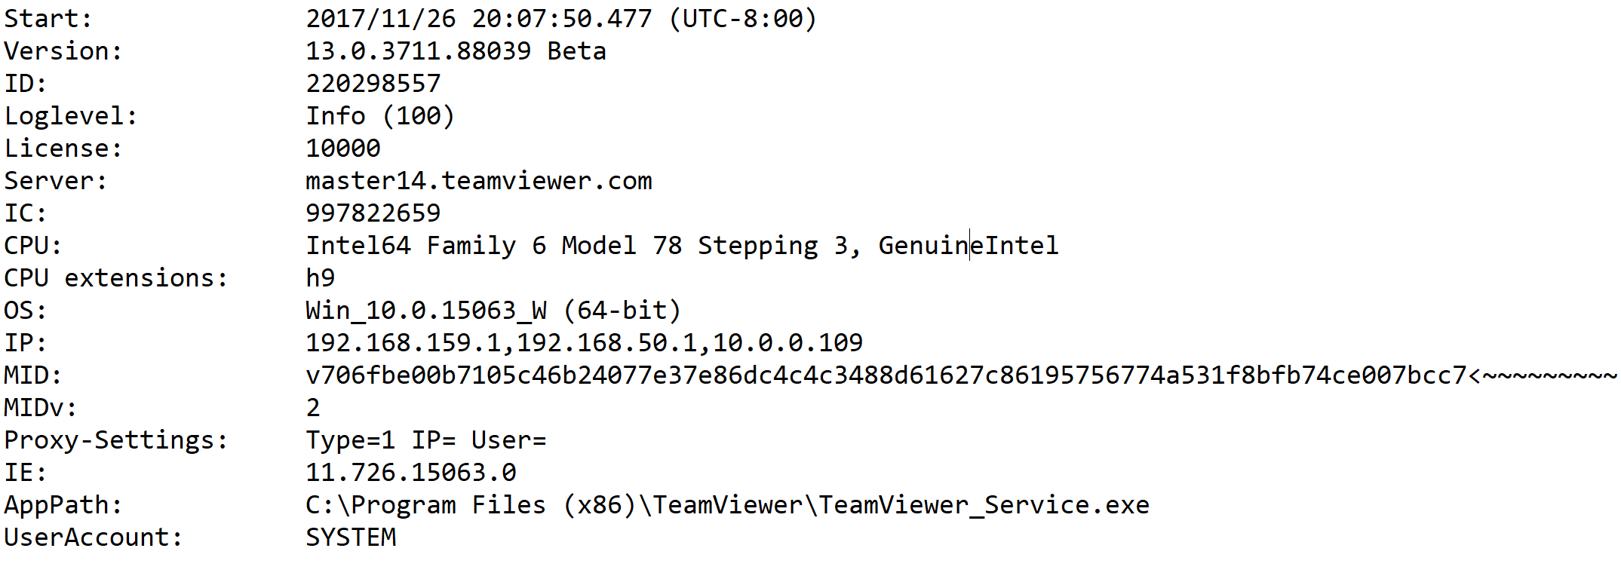

* To have more secure connections choose a 10-digit pass code instead of a default 4-digit passcode option. And check the option to change it after every session. By default, until the TeamViewer client logouts of the application the same passcode is used which is not secure.

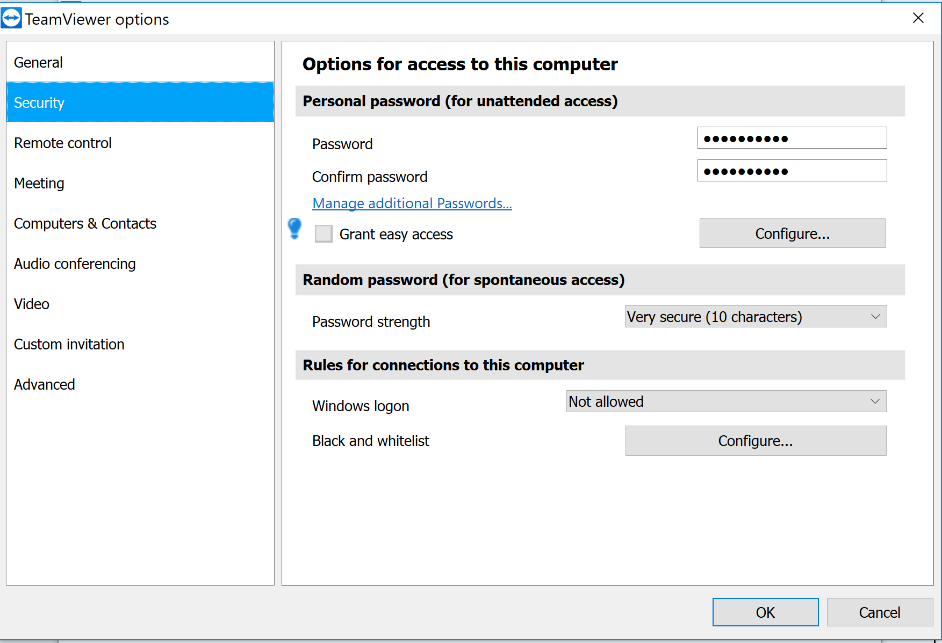

We also installed TeamViewer on Android phone for a few test cases we defined and analyzed the security features during connection between peers.

## **How we executed**

* Used a Wireshark dissector lua code and saved it in personal plugin directory.
* Can use either CLI tshark commands or GUI WireShark to capture and observe the team viewer packet flow. Make sure that the init.lua file has disable_lua field set to false.

CLI:

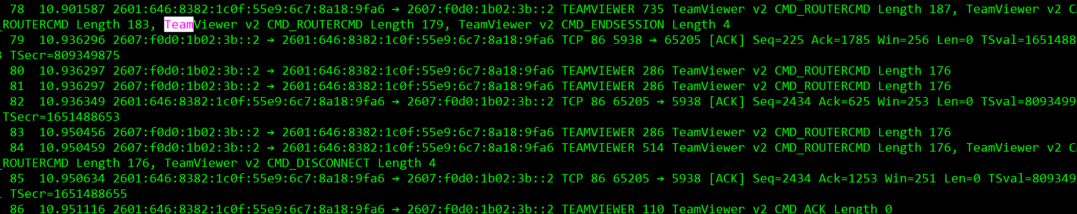

GUI:

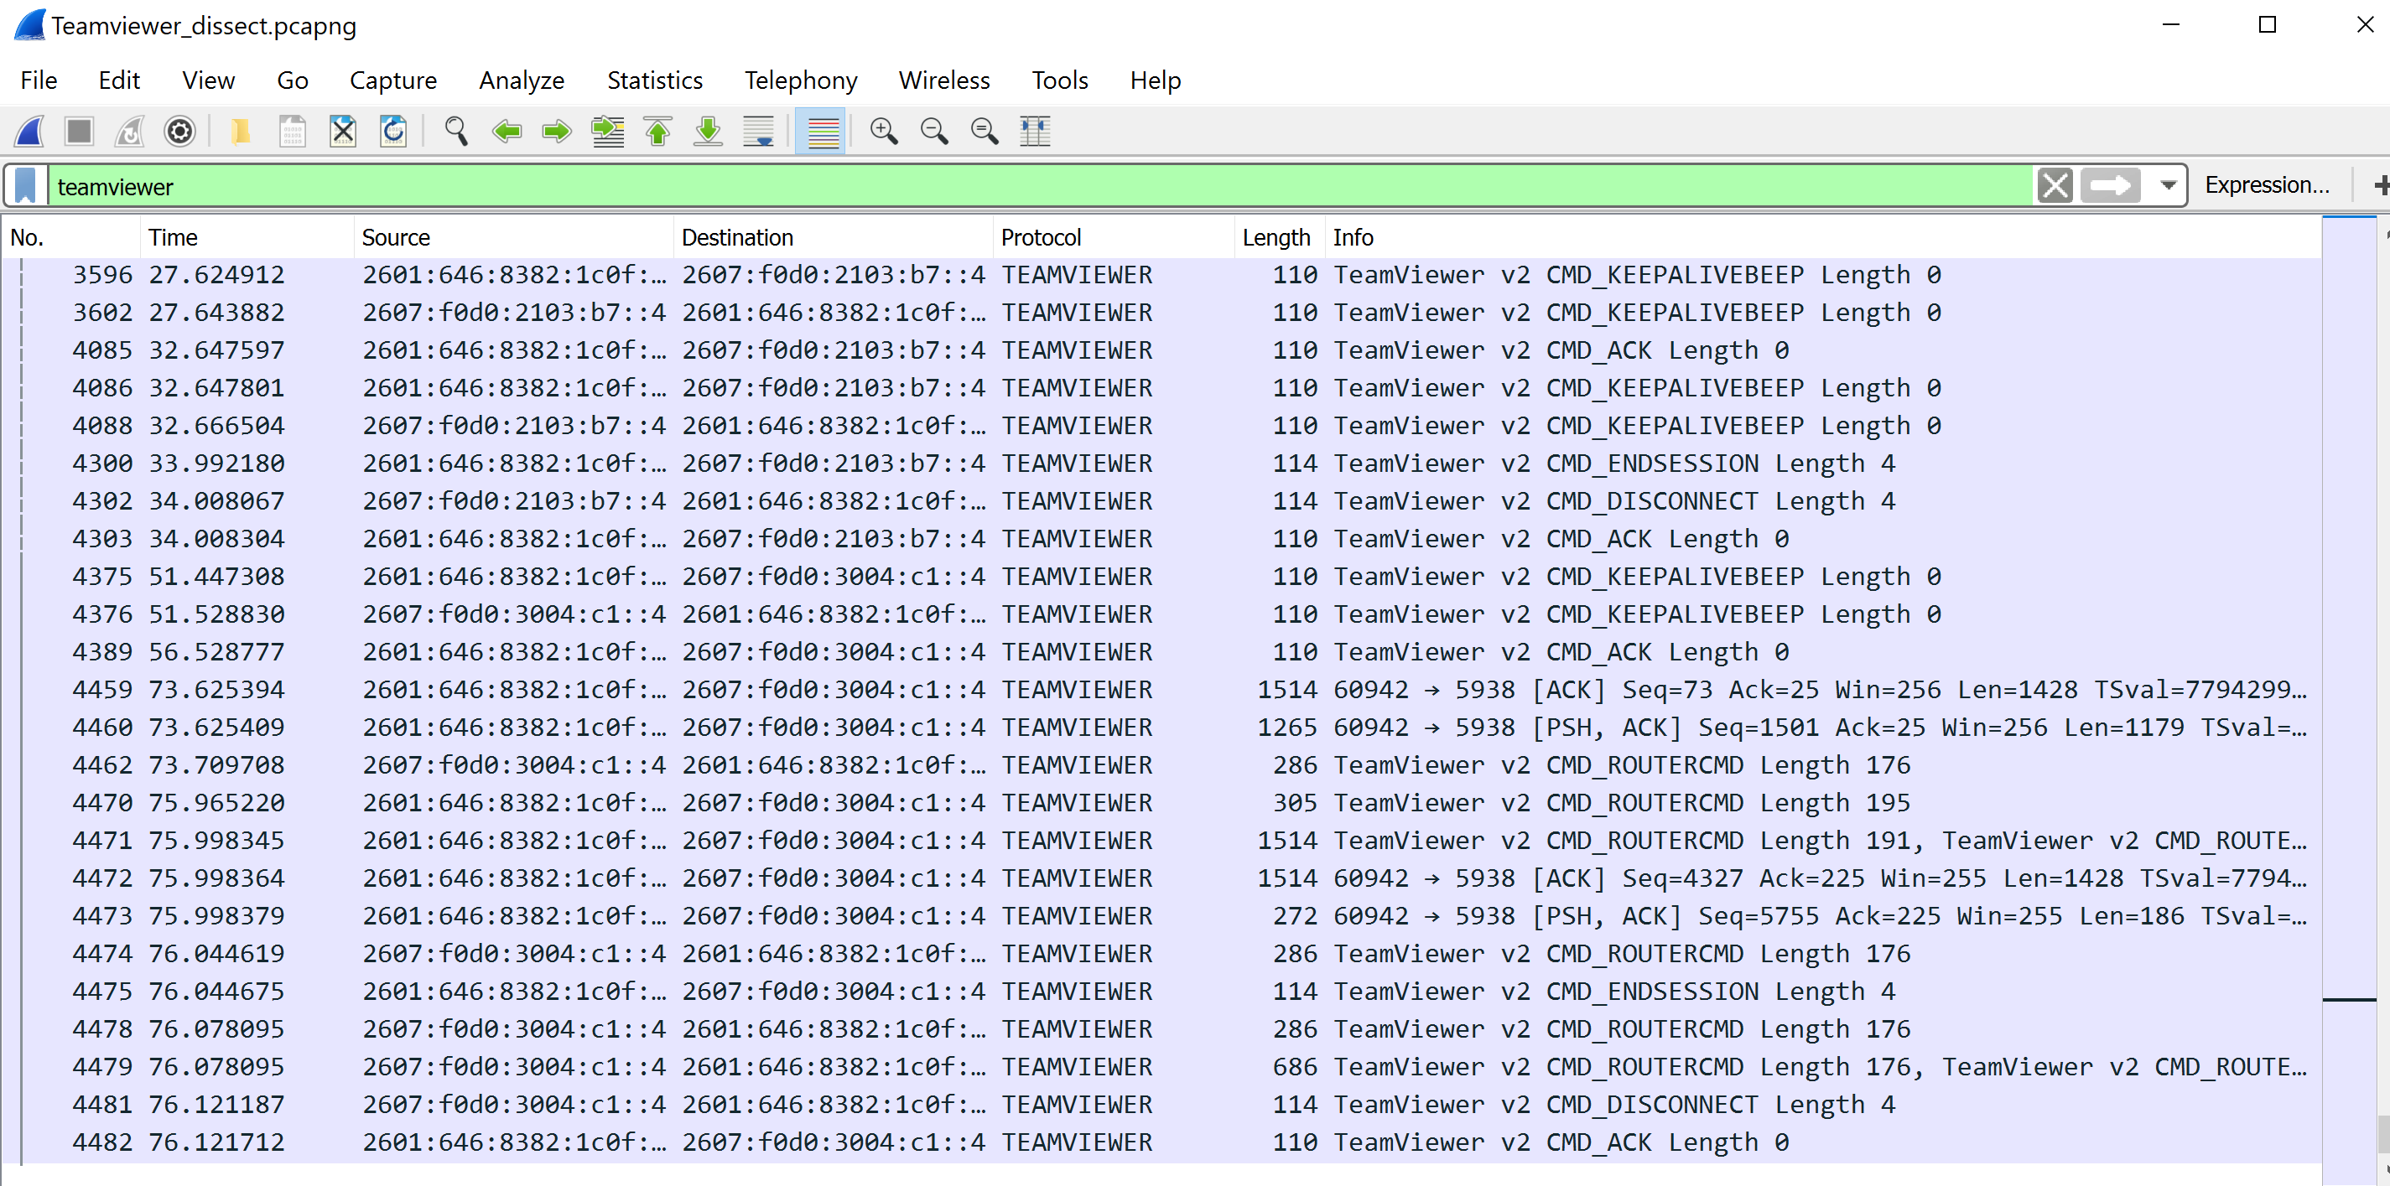

* Enter the TeamViewer ID and the passcode of the other TeamViewer client we wish to connect.
* Observe the packet captures by using WireShark or tshark diplay filter as TEAMVIEWER.

Tshark display filter: tshark -X lua_script:teamviewer.lua -Y teamviewer -i Wi-Fi

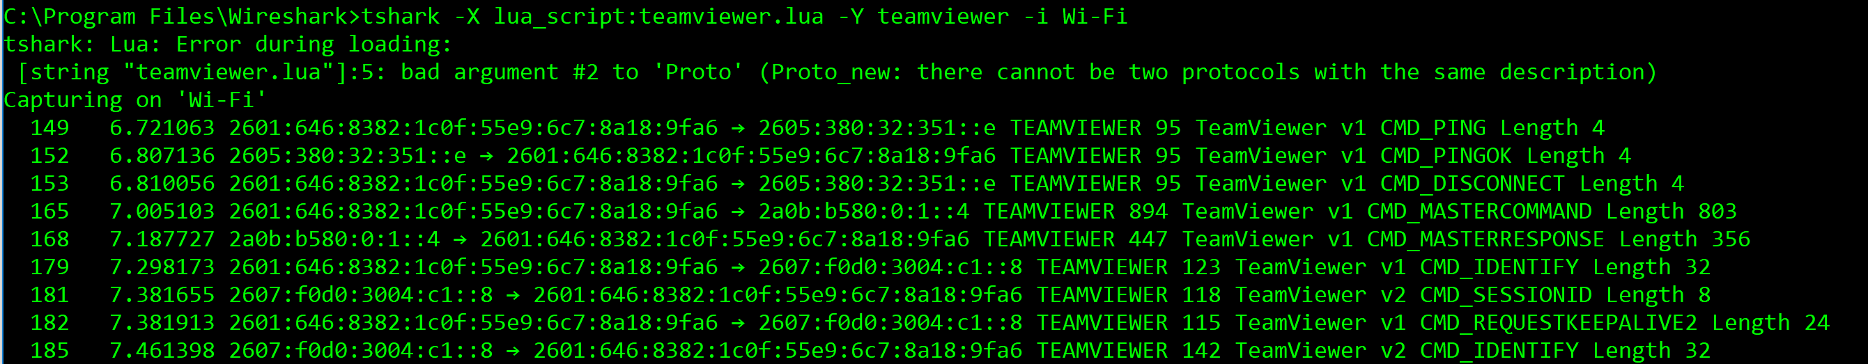

Wireshark display filter:

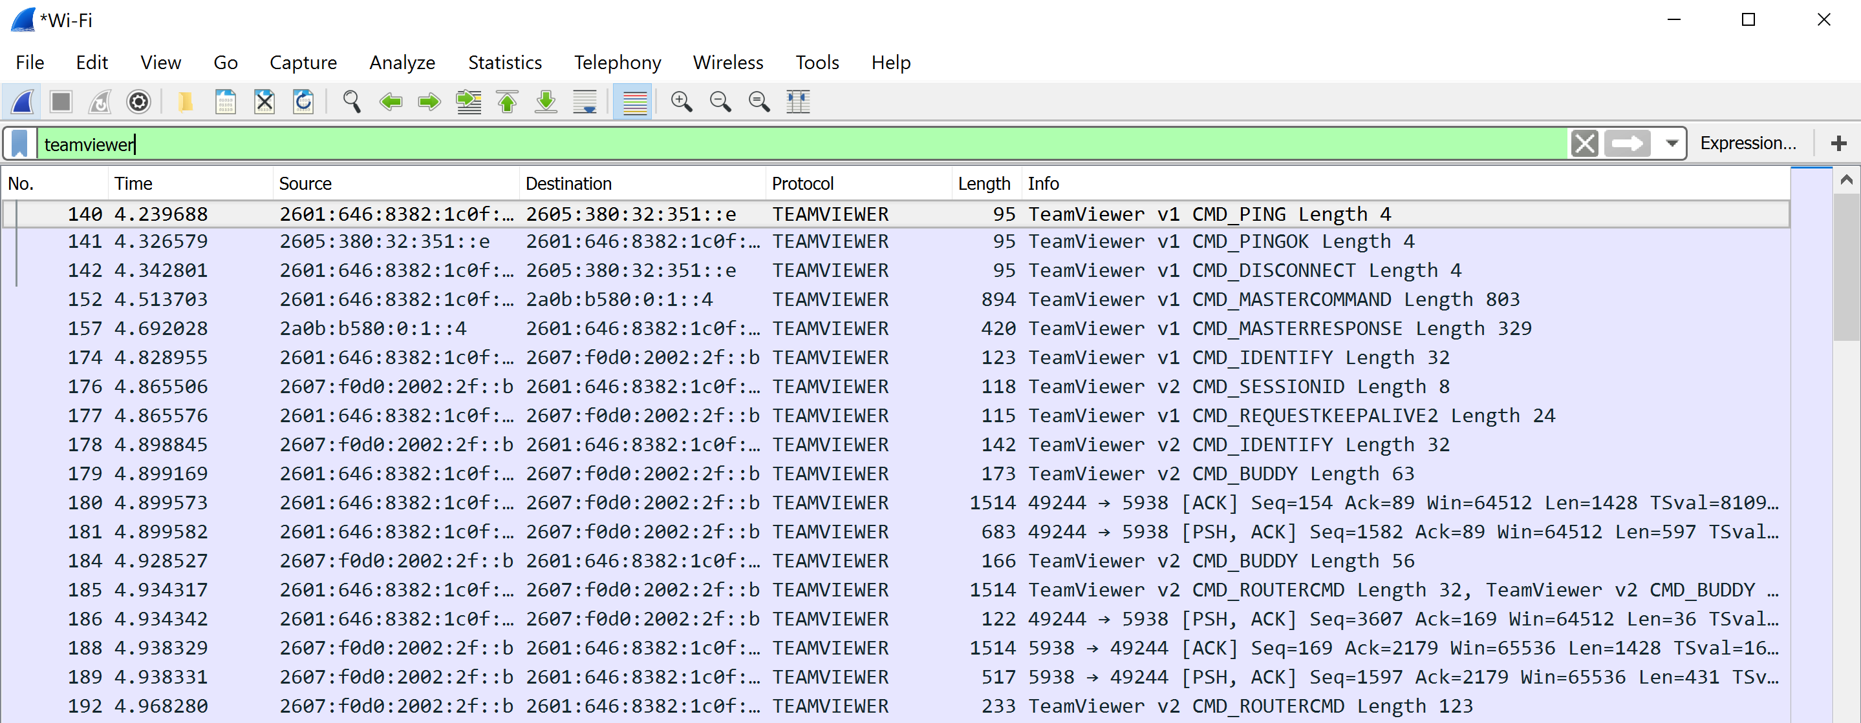

# **Capture and Analysis**

## **Initial Handshake**

TeamViewer Master

CMD_PING

Team Viewer Client

CMD_PINGOK

CMD_DISCONNECT

CMD_MASTERCOMMAND

CMD_MASTERRESPONSE

#### Wire Shark Capture

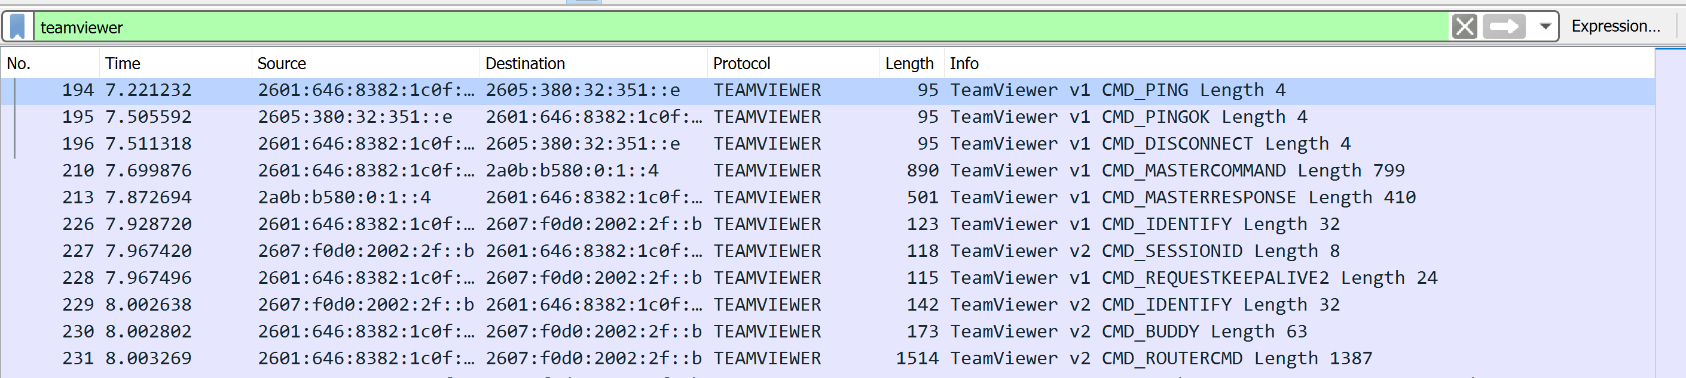

### **CMD_PING**

This command is used to check if the system can reach TeamViewer infrastructure. The client sends a ping to the TeamViewer Master.

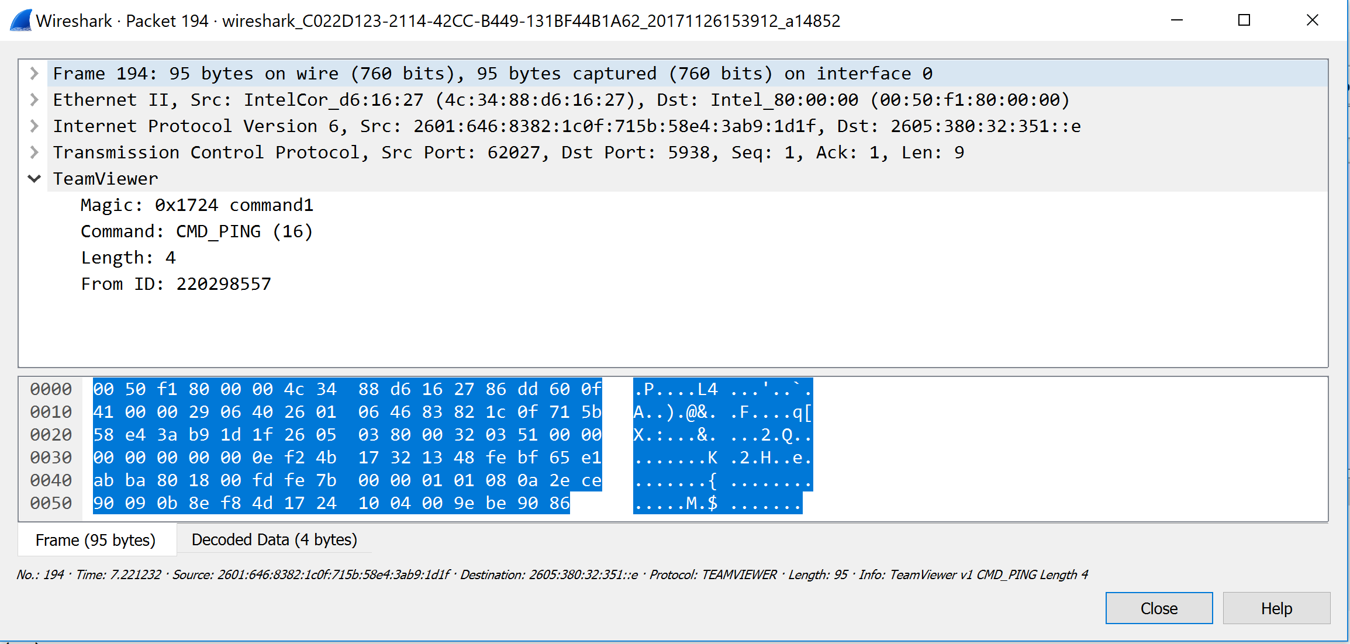

* 1. **CMD_PINGOK**

This command lets the client know that it is reachable. It is just a ping response to the request.

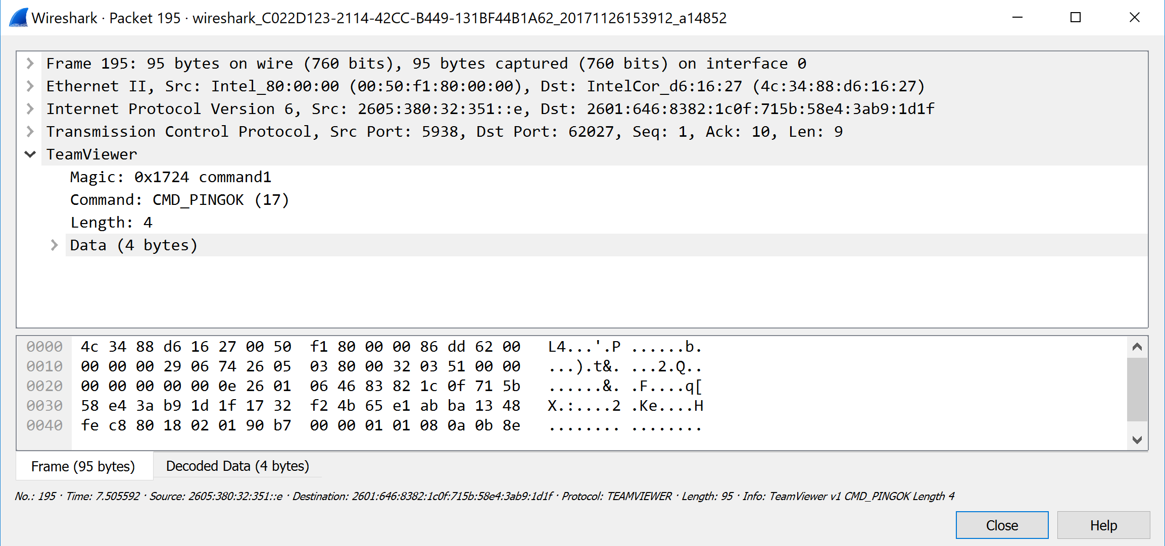

### **CMD_DISCONNECT**

After making sure that the client is reachable to the TeamViewer Master it disconnects.

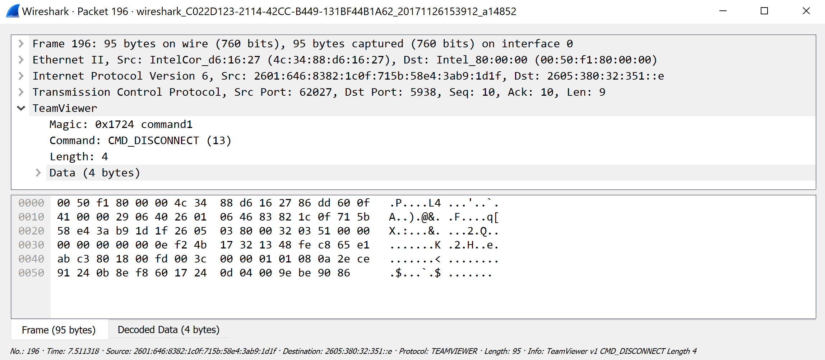

* 1. **CMD_MASTERCOMMAND**

The client sends this command to the TeamViewer Master Server to let them know that it is all set for the communication. It includes the Client’s 9-digit Identifier of the client. It is the same ID that is displayed on the client when they login to TeamViewer Application.

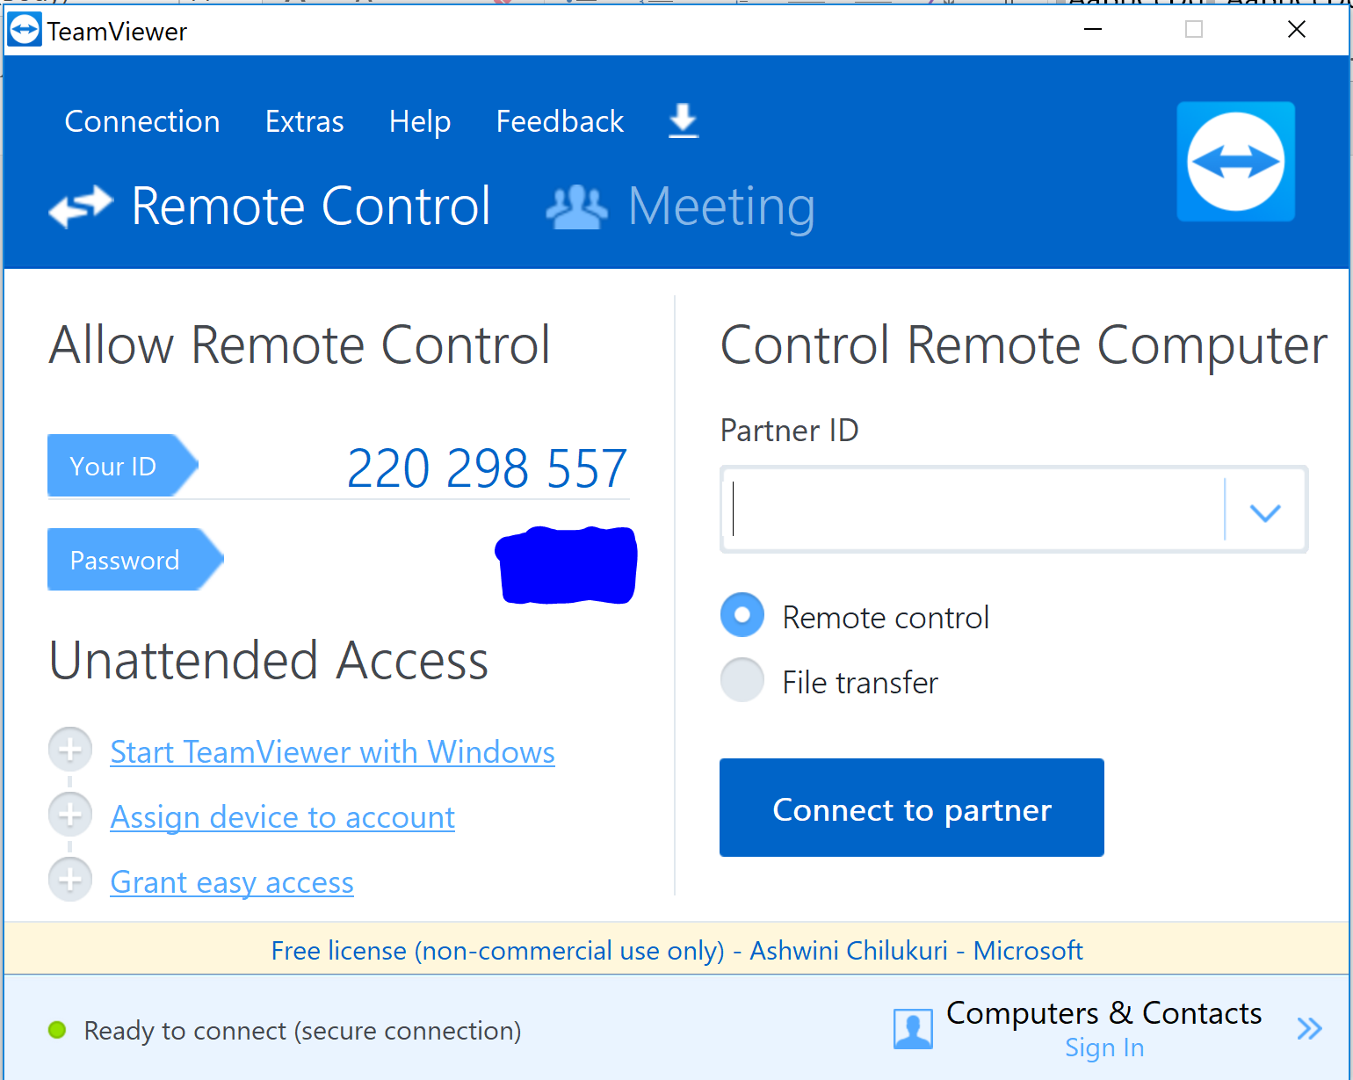

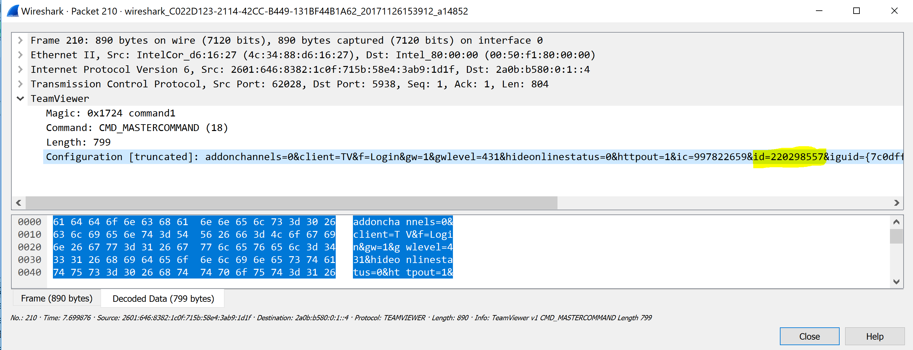

# **CMD_MASTERRESPONSE**

This command is the response for the previous command, CMD_MASTERCOMMAND. The Master responds with the IP Addresses of the KeepAlive Servers with which the clients communicates later.

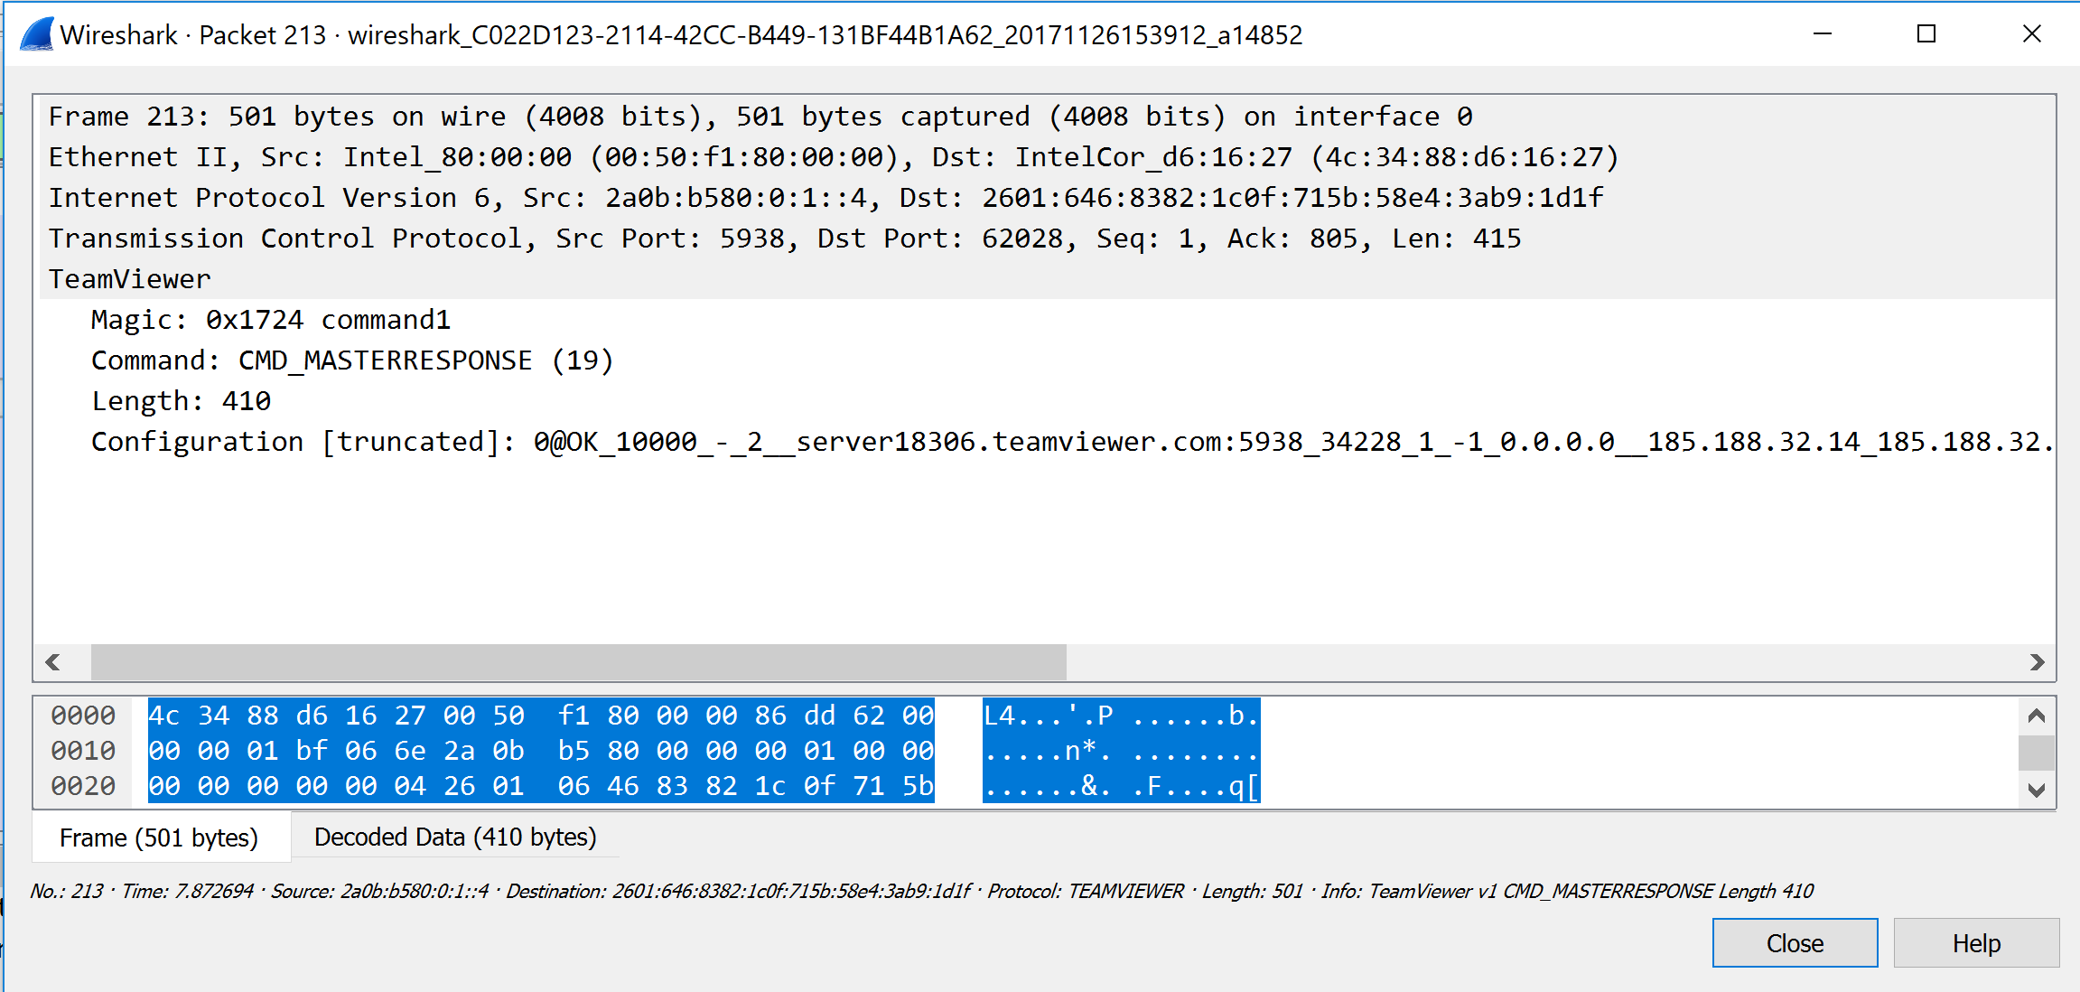

## **Keep Alive Server Connections**

Once the router connects to the Keep Alive server it will get online and has a steady connection. The outbound connections are through the Master while the inbound connections are through the Keep Alive connection. For the communication between the clients possible both the team viewer clients must complete the initial setup with the Keep Alive server. The server gives each client a unique 12-digit identifier called the client ID based on the mac address.

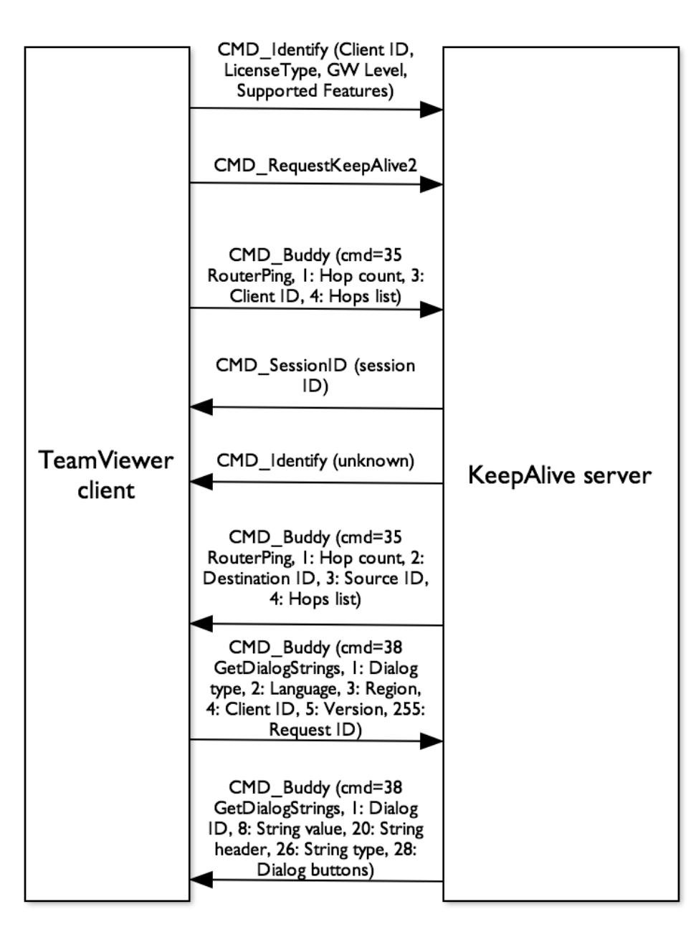

# **CMD_IDENTIFY**

The Client sends its Identification information to the Master. It includes Client Identifier, its License Type, etc.

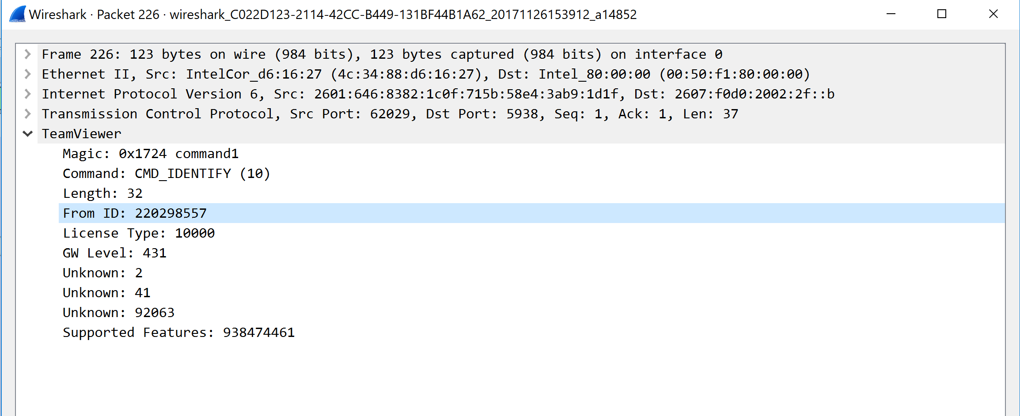

### **CMD_REQUESTKEEPALIVE**

The client requests the Keep Alive server to keep its connection online.

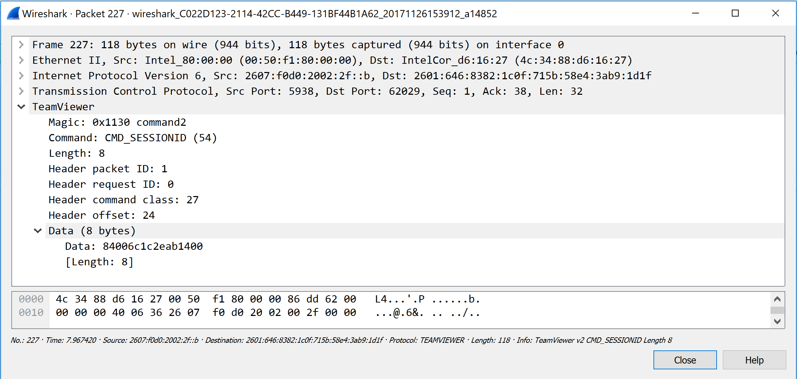

### **CMD_SESSIONID**

The Keep Alive Server sends the session ID to the client and makes sure that the client is online for getting connected to other devices.

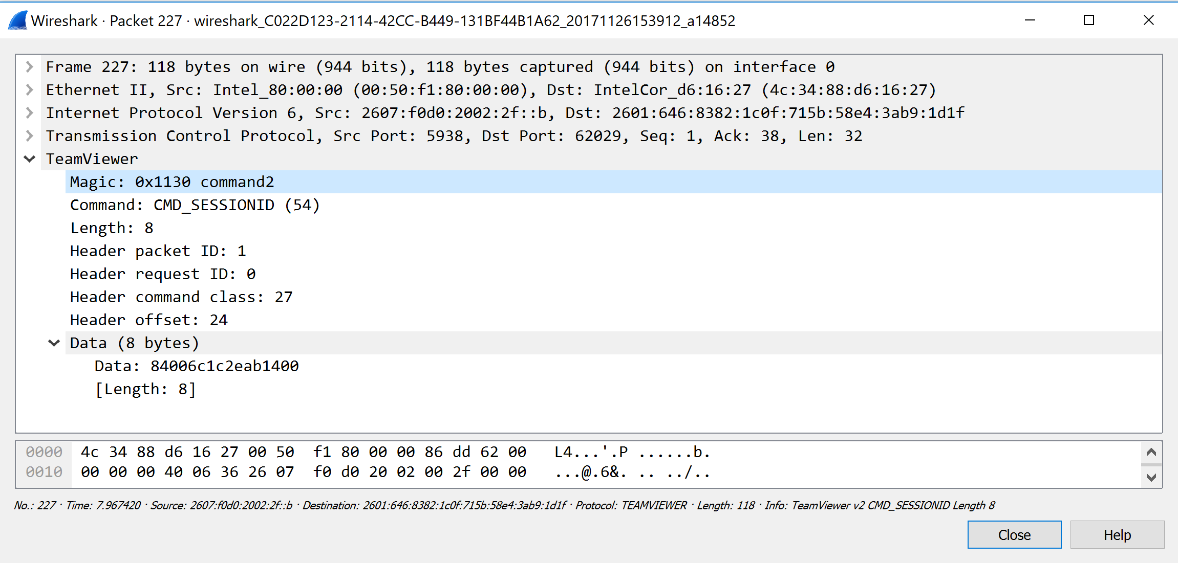

### **CMD_ROUTERCMD**

It communicates with other devices using these commands.

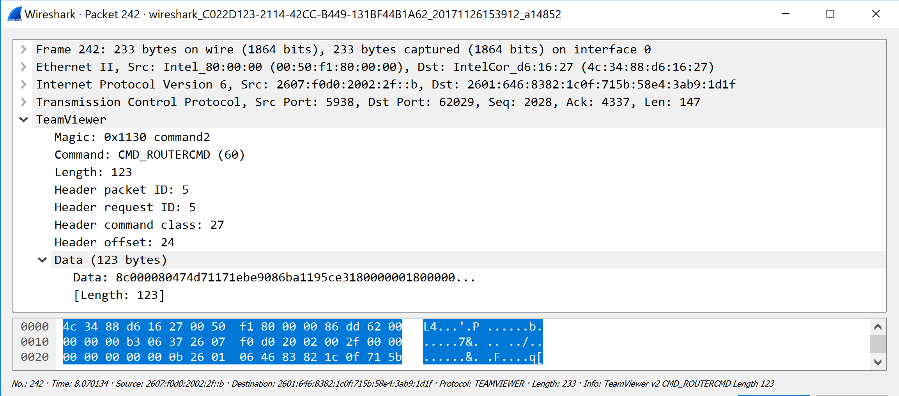

### **CMD_BUDDY**

The Keep Alive server has its own network ID. These commands are used to make sure the device is reachable. They are even used for string synchronization.

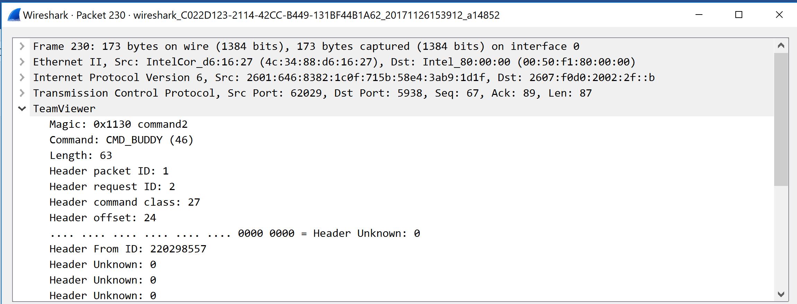

### **Status of TeamViewer**

Once the connection with the Keep Alive server is established by the client its status changes to Ready to Connect (Secure connection) and the color turns green.



Both the clients must be in “ready to connect” to start a session. Once the connection is established with the Keep Alive Server either of the client who wish to take the remote access must enter the other client’s TeamViewer ID and passcode to begin the session. Each time a user access one system the logs are recorded which includes the client’s TeamViewer Identifier.

## **Complete Connection**

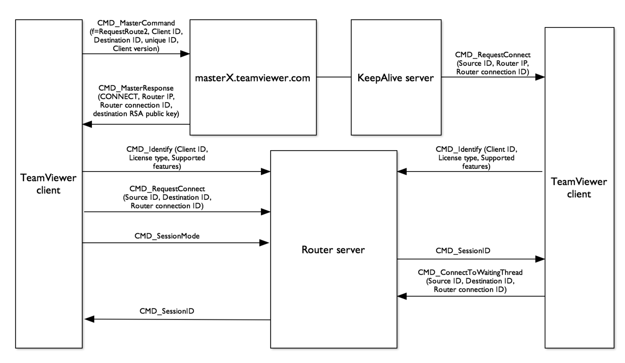

## **Final Hand Shake – Logout**

The Client ends the session by sending an end session command. The server responds with a Disconnect message for which the Client acknowledges.

TeamViewer Server

TeamViewer Client

End_Session

DISCONNECT

CMD_ACK

Below is the Wireshark capture of the same



# **Troubleshoot**

Faced issues while trying to use the dissector for Wireshark capture and as we have initially placed the lua program in the global plugin directory itself.

Created a personal plugin folder - C:\Users\ashwi\AppData\Roaming\Wireshark\plugins. The location is specified at “Wireshark 🡪 help 🡪 folders 🡪 Personal Plugins”.

Pasted the lua file in the personal plugin directory and started capture on Wireshark and started observing packets with Protocol field containing TeamViewer.

Personal plugin directory:

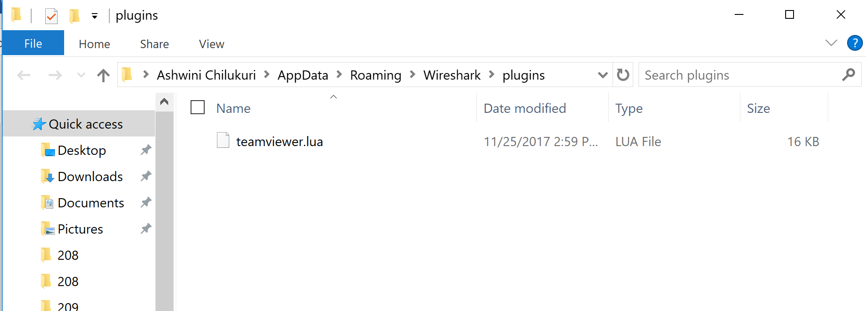

**Init.lua**:

The disable_lua must be set to false so that the WireShark Dissector works.

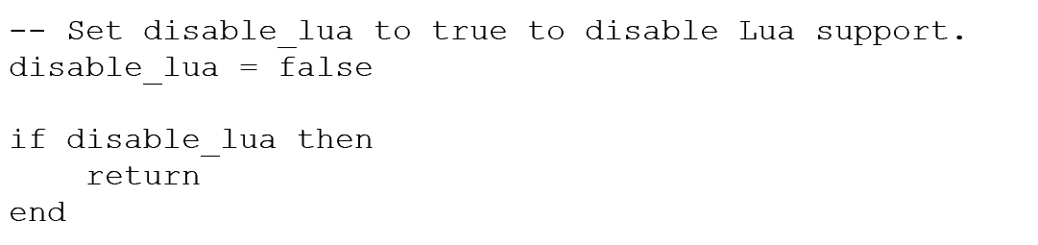

Below is the screenshot of the Global plugin directory:

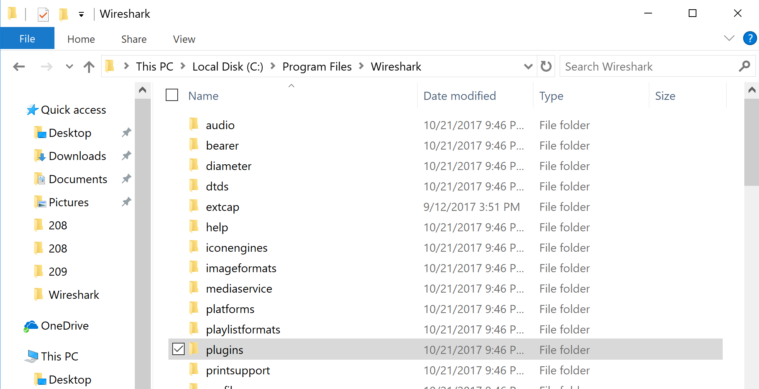

## **Security**

TeamViewer uses RSA 2048 Public-Private Key pairs to exchange symmetric key for a session. This AES (256 bit) symmetric key is used for exchange of information which in this case is the remote connection or file transfer.

### **Process:**

Clients send their public keys to the master

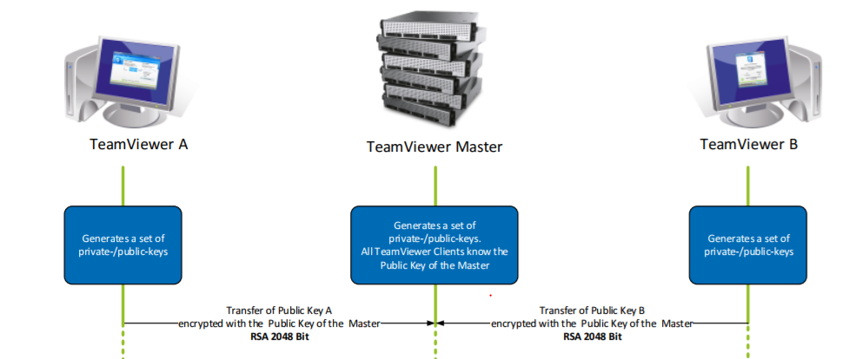

Initially, on opening TeamViewer, the clients (TeamViewer A and B in this example) generate public and private key pairs. The TeamViewer Master systems also have their own public – private keys generated. All the TeamViewer clients usually know the Public key of the master.

TeamViewer A first transfers its own public key to the TeamViewer Master. This is encrypted using Master’s public key. TeamViewer B does the same. As of now only the master has public keys of both the clients.

Client A requesting public key of client B from master

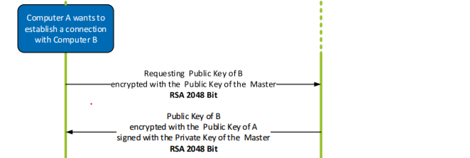

If Client A needs to establish a connection with Client B it needs to know the Public key of Client B. To obtain the Public key of B, Client A requests the Master. This request is also encrypted with the Public key of the Master. Master replies with Public key of Client B. This is encrypted with Public key of Client A. Now, Client A has learnt the Public Key of Client A.

Client A generates and transfers the symmetric key to Client B

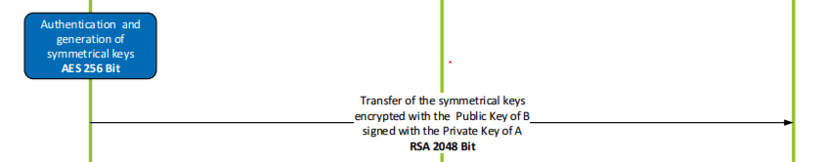

Client A generates a symmetric key and sends it to Client B. This transfer is encrypted using Public Key of Client B and signed with Private Key of Client A. At this point, Client B receives the Symmetric key but does not know the public key of A to decrypt and obtain the symmetric key.

Client B requests for Public Key of Client A from the Master

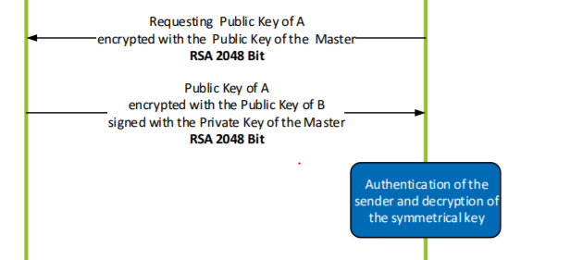

Client B requests the master for Client A’s public key. Master replies with Public Key of Client Key. Both these messages are encrypted with corresponding receiver’s Public Key.

At this point Client B will be able to authenticate the sender and decrypt the symmetric key.

Communication between Clients

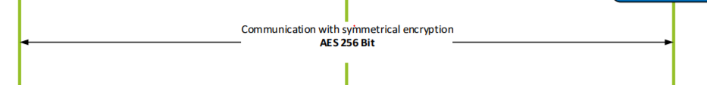

Client A and B can now communicate with each other using the symmetric key(AES 256)

# **Authentication and Password Encryption**

To ensure authentication and password encryption, Secure Remote Protocol and Password Authenticated Key Agreement protocol is used.

## **Secure Remote Password (SRP) protocol**

When we trigger the TeamViewer application, we can observe that an ID and password field are displayed in the **Allow Remote Access** field.

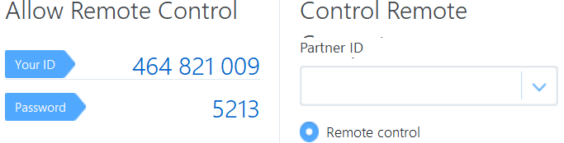

As we can observe from the screenshot, the length of the password is extremely small ie. 4 digits in size. The maximum number of combinations that need to be tried to crack a four-digit password is 10 to the power 4 which is 1000. Even though the size of the password is small, TeamViewer can establish a secure connection between the two hosts (client and remote) and prevents man-in-middle attacks. This is done through the Secure Remote Password protocol.

When a user signs into his/ her account, the SRP is used for the connection establishment between the TeamViewer server and host machine (user). The reason this is immune to man-in-the-middle attacks is:

1. The password is not store on the server. Even if a hacker gains access to a session and tries communicating with the server to retrieve the password, he/ she will find nothing.
2. The password is not sent over the internet. Sending an authentication token/ key over the internet can lead to a man-in-the-middle attack which in this case is not possible.

**How does this work?**

The password is sent to the server/ nor is present in it, by using the SRP which is type of augmented PAKE (Password-Authenticated key agreement), the client (user machine) can prove to the server that it has the password and is the rightful owner of the account. The information that is sent to the server is neither the password nor any other information related to the password and hence is worthless for a man-in-the-middle attacker.

Following are the properties of the SRP protocol:

1. Client need not store the password on the host machine. If an attacker gets access to the host machine, he still does not get any information about the password.
2. Server does store the password.
3. Server never knows the password of the user trying to gain access.
4. These properties eliminate the chance of a replay attack.
5. The attacker cannot brute force the password offline even if he/ she has total information about the authentication session.
6. The shared secret between the server and the host is different each time.
7. No private keys need to be stored on the machine.
8. Larger public parameters can be easily added to boost the security measures taken.
9. Does not need a trusted third party.
10. Standardized under RFC 5054.
11. The SRP authentication & Key Exchange System has been standardized under RFC 2945.

The SRP is a two-step protocol:

1. Setup phase:
   1. Client chooses a password.
   2. It calculates the verifier.
   3. Sends verifier to the server.
   4. It does not contain the password/ any information regarding the password.
   5. It contains the hash of the password.
   6. This phase cannot perform any authentication.
   7. This phase creates a verified process for the server to verify during the authentication phase.
2. Authentication phase:
   1. The user puts his password in to the client machine.
   2. This is used as input for SRP protocol.
   3. A shared secret key is obtained between the client and the server using the Diffie-Hellmann key exchange process.

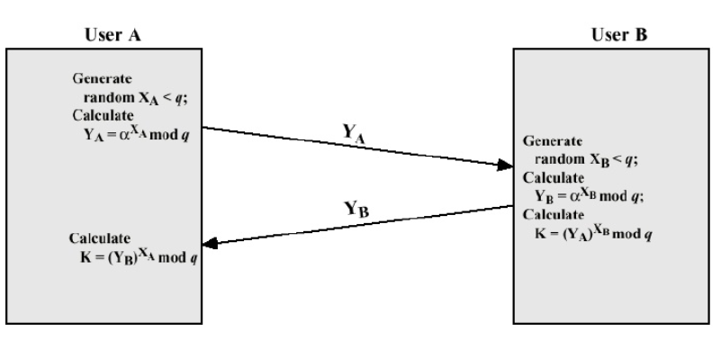

Above is the picture of the Diffie-Hellmann key exchange process.

* 1. The client proves to the server that it has the key needed for the server to authenticate the client.
  2. The data transmitted by the client is a hash value calculated between the key obtained and information related to the server like the public key of the server.
  3. The server calculates its own hash value.
  4. Both these hash values are compared.
  5. If both are equal, the client is authenticated.

Below is the figure describing the process that takes place in the SRP protocol.

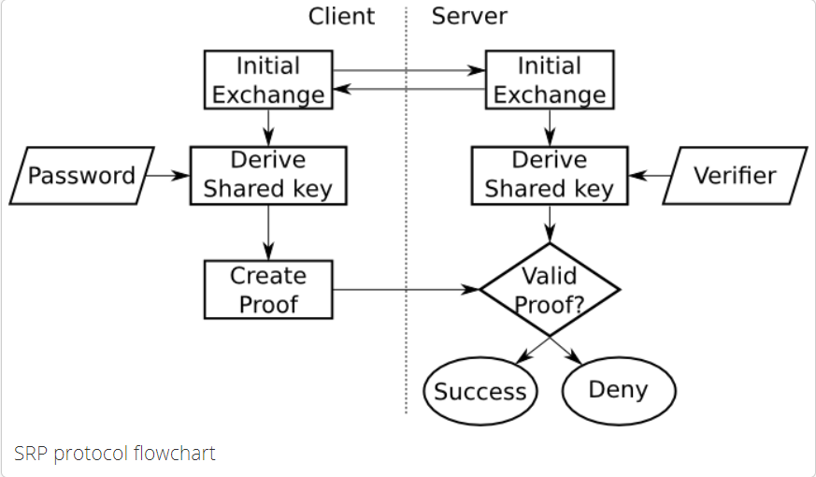

The decision block at the end validates the hash sent by the client and if it is valid then the client is given access to the session else denied.

**Advantage**:

A single run of the SRP protocol can be sufficient to prove the presence of a token with the client. The prevention of multiple runs does allow the attacker to have information in pieces ie. Through each transaction and attack the system. If an attacker wants to get into the session, he should be able to guess all the keys at the same time making it extremely difficult for the system to be hacked.

Below are the snapshots of the implementation of the protocol in Python:

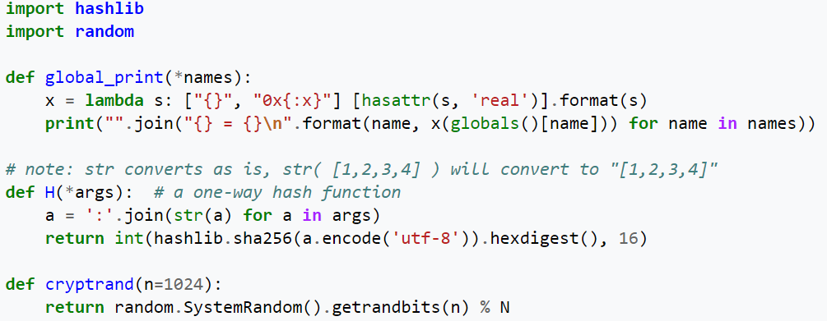

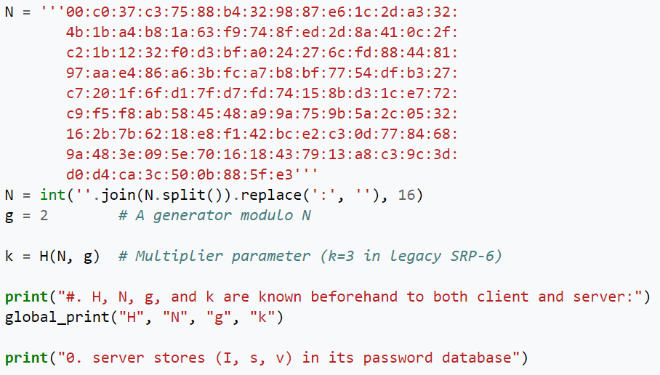

Steps of the Implementation:

1. Client sends username and public key to the server
2. Server sends the client its salt value S and public key
3. Client and server calculate the random parameter
4. Both client and server compute the session key
5. Client send proof of session key to the server
6. Server sends proof of session key to the client.
7. Session authentication is complete.
8. The client is logged into his session.

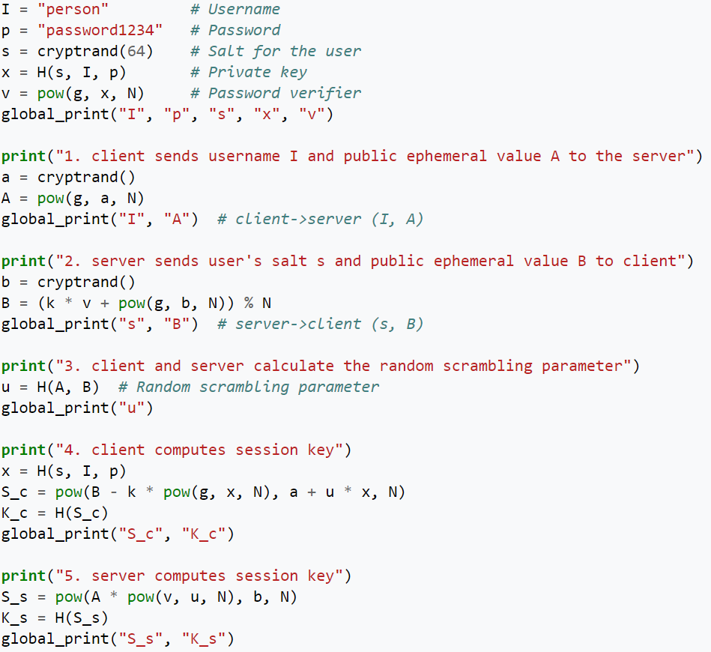

All these functions are executed in a sequential manner. Any change in the order of execution could lead to the crashing of the system and the codes that get generated can be ineffective for real world usage.

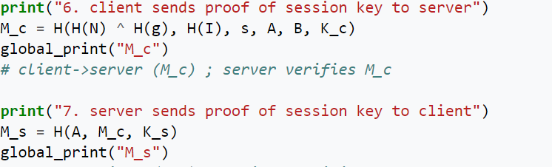

## **Password Authenticated Key Agreement**

Using PAKE (Password Authenticated Key Exchange), two or more clients can generate a cryptographic key based on knowledge of one of the client’s password using exchange of messages between them. No other information is usually required other than this password. This is used along with SRP. This way password cannot be guessed, or brute forced by anyone unauthorized.

## **TeamSpy**

In 2013, CrySys Lab (Laboratory of Cryptography & System Security) revealed to the public details about the attacks that happened through the TeamViewer application for a long time. The process of the attack was straight-forward. The attackers installed the TeamViewer software on the victim’s machine and then modified the session through DLL hijacking which they used to get remote access.

The report from the lab revealed that these attacks have been taking place for a decade and hence have termed the word **TeamSpy**. Various attacks that can be done through modification of the DLL session of TeamViewer:

1. Extract information from files
2. Copy files from the remote host
3. Install malicious software

Attackers were able to extract different types of files from the machine ranging from Microsoft word, Excel documents, PDFs and files the contained password and other secret information regarding the victim. An interesting observation was found in the report – it stated that the attackers were also searching for files with pgp and p12 extensions. These files are used to store cryptographic keys and metadata.

Following are a few high-profile victims targeted by the group

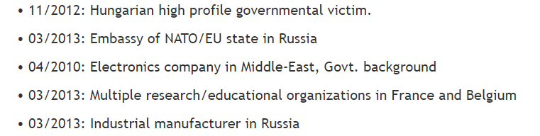

**Avicap32.dll** was the file that was used all the sessions for DLL hijacking. Almost all these files found on the victims’ machine were found to be modified. TeamViewer management countered the accusation saying that the remote host user will be notified of a session. The session will be changed every time the application is restarted and unless the host user sends his / her credentials along with starting the application on their machine, there was no way for the attacker to get into the system. <http://www.crysys.hu/teamspy/teamspy.pdf> is the link to the complete report published by the CrySys lab regarding TeamSpy. <https://www.symantec.com/connect/blogs/teamspy-backdoor-viewer> is a blog published by Symantec describing the attack on TeamViewer.

Below is the screenshot of the heatmap of countries effected by TeamSpy

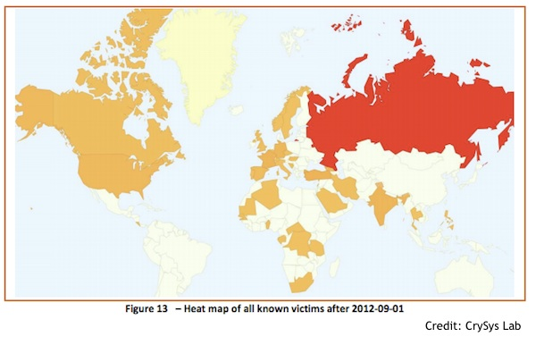

There are various other malicious software’s that have been making use of TeamSpy. Shade is the most famous amongst all of them. Shade is a form of ransomware. A ransomware is a malicious code that encrypts all the files on a victim’s machine and demands money to be paid to the attackers before getting a key to unlock the encryption.

Shade is an evolved form of ransomware. It can:

1. Download more malicious content
2. Install software on the host
3. Communicate with the attacker
4. Install TeamSpy for remote host control

These additional features for a ransomware are hard to decode and using TeamSpy for these activities has increased the power that is given to the attacker. Below is the screenshot of the Wireshark capture of a TCP connection when the Shade encryption process was running on the host machine.

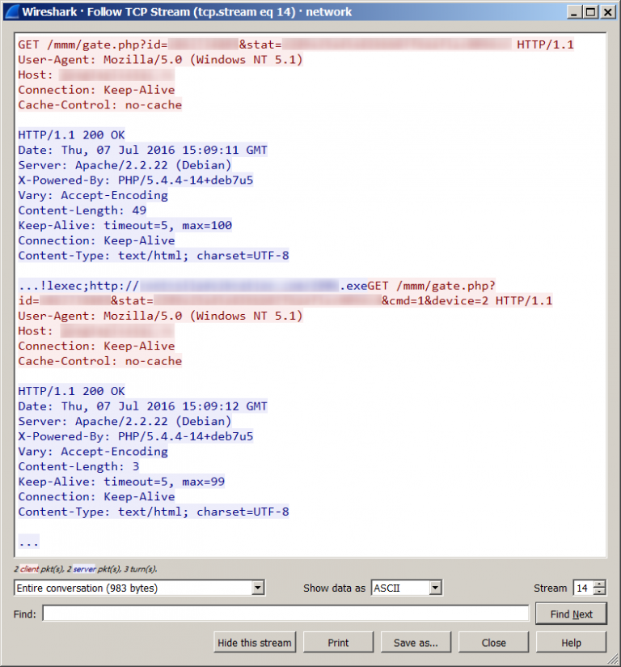

## **Observations:**

Transport Layer Security/ Secure Socket Layer

TLS v1.2 (RFC 5246)

SSL is a predecessor of TLS. SSL provides authentication, integrity and confidentiality between the clients using TeamViewer. It runs over TCP. Below is a screenshot of the capture which shows TLS being used.

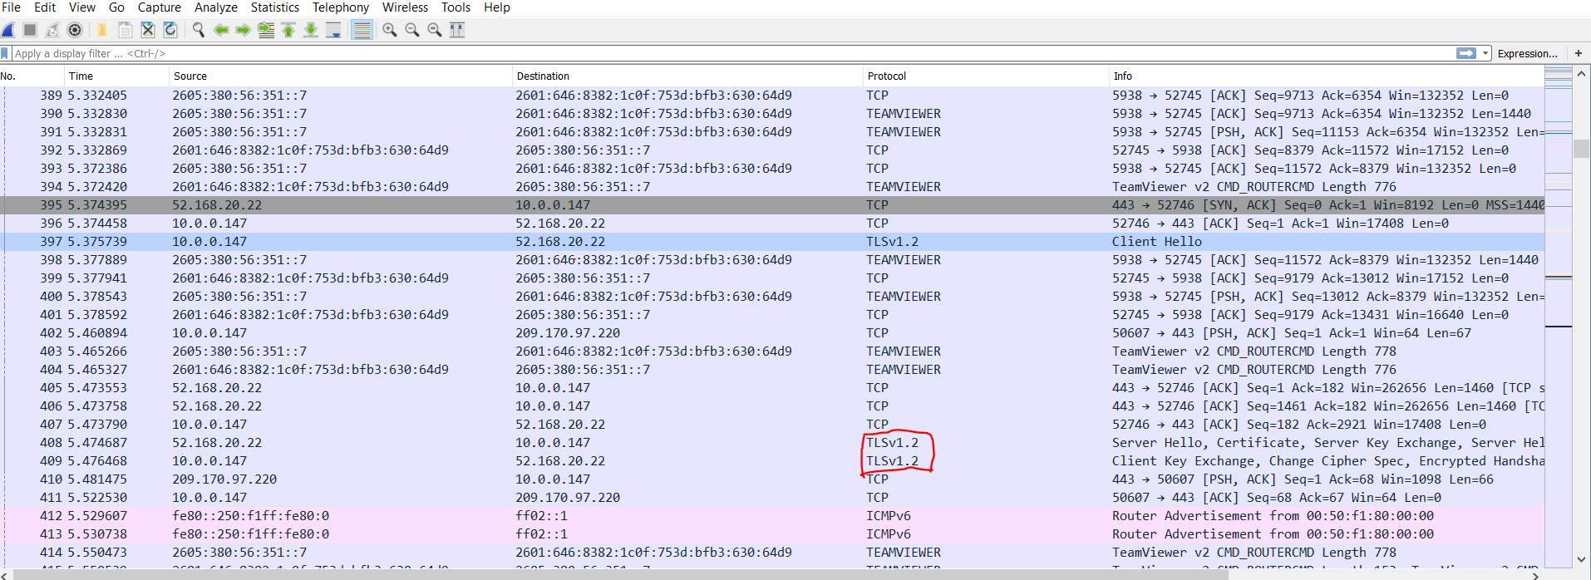

## **TLS packet capture and analysis**

**Client Hello**

Client Hello specifies the highest TLS version it supports. In this case it is TLS v1.2. It also contains a random number, list of suggested Cipher Suites, list of compression methods and other extensions.

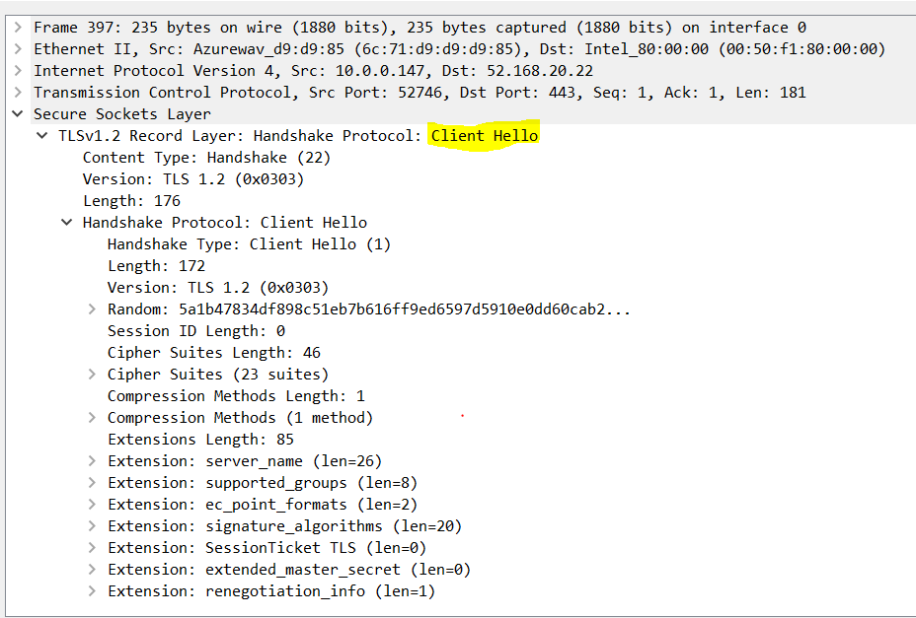

Server Hello

The server then responds with a Server Hello message. This contains all the chosen values from the ones the client offered previously. It decides the TLS version. This would be the highest version that both the server and the client can support. In this capture we were able to observe the certificate that the server sent along with Server Hello. We were also able to view the encrypted certificate and see which Master server issued it. Along with the certificate, the server also sent the **Server Key exchange** and **Server Hello** packets. These packet capture have been highlighted in the screenshot below.

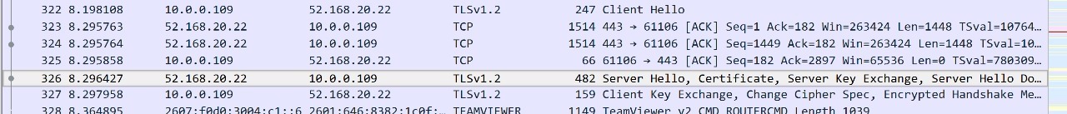

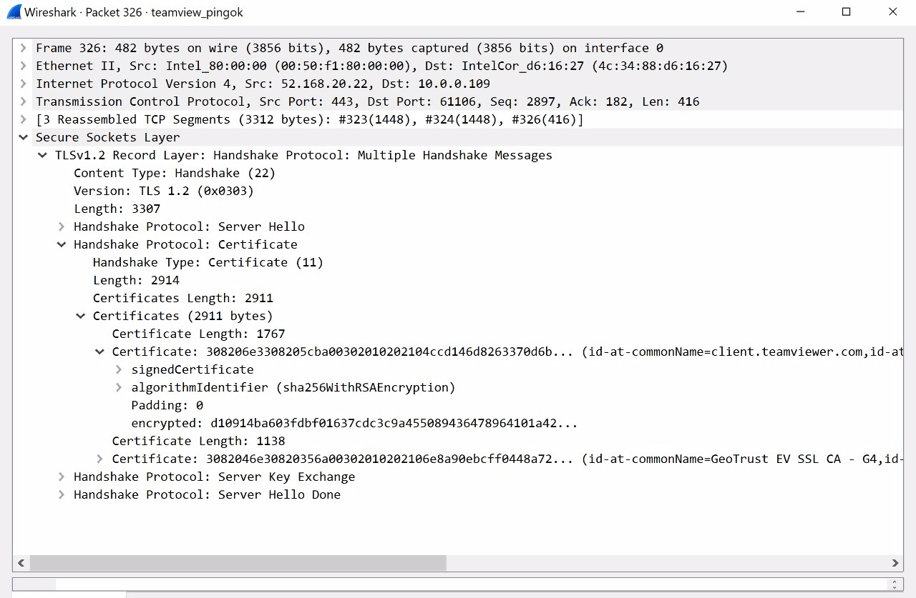

## **Client Key Exchange, Change Cipher Spec, Encrypted handshake message**

Client Key Exchange: This may contain a premaster secret, a public key or nothing. In our capture we observed length, type of message(Handshake) and TLS version (TLS v1.2). We were also able to observe Diffie-Helmann client parameters.

Change Cipher Spec:

This is used to change the type of encryption being used between the TeamViewer server and the client and notify each other about it. Due to this, there is no confusion between them about the type of encryption being used. In this packet we were able to observe content type, version and handshake protocol.

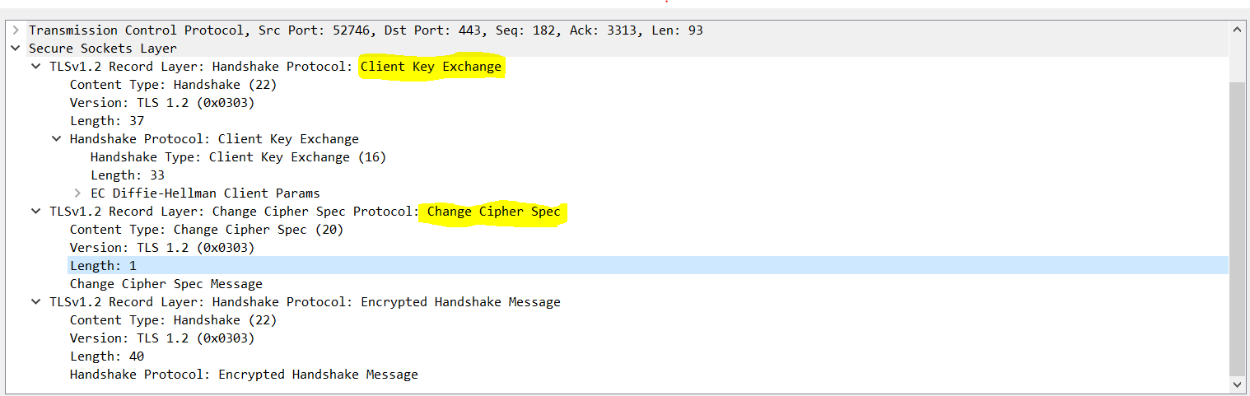

## Objective:

The objective of this project is to analyze the TeamViewer application and understand the protocols working beneath. We achieved the above by performing the following:

1. Set up TeamViewer peers

2. Observe their communication using Wireshark captures

3. Study the protocols observed and document what we understand

4. Analyze how secure the application is and understand the protocols used for it

5. Study about the attacks that happened with or through the application

# **Test Cases**

* 1. Two Windows 10 Laptops as peers

We connected two Windows PC and analyzed captures using Wireshark on interface en0(Wi-Fi).

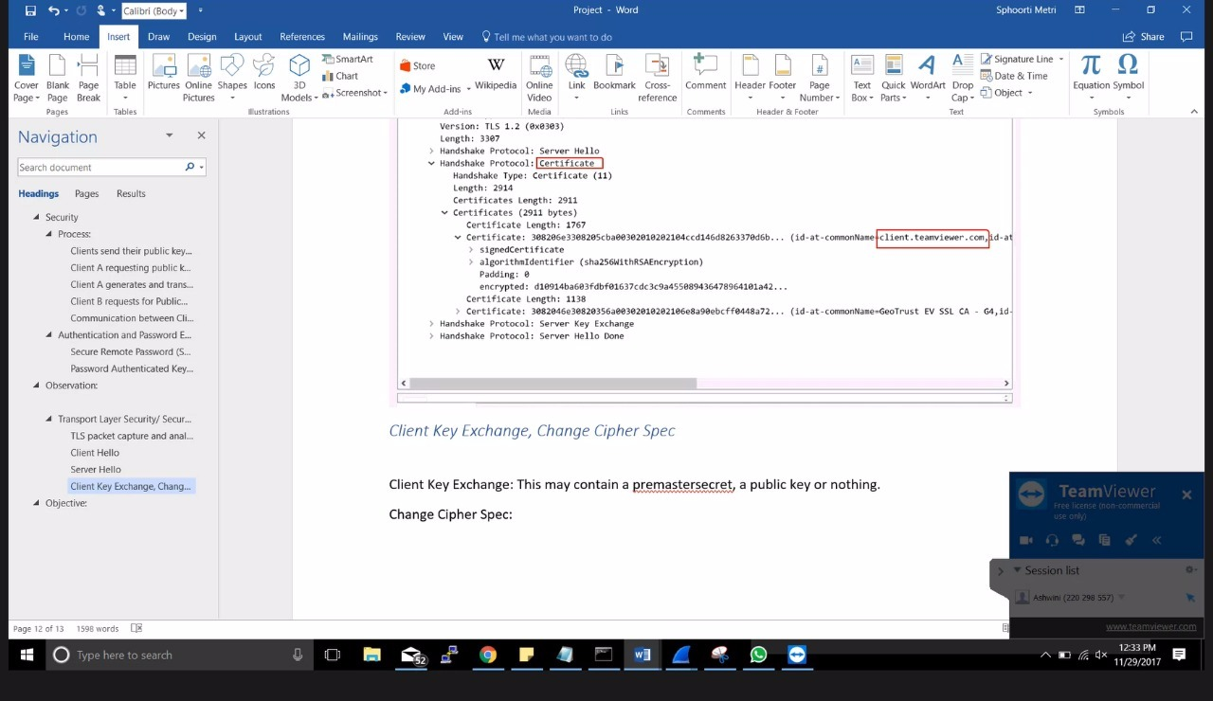

* 1. Android phone having remote access over Windows 10 PC

After downloading TeamViewr application on android phone, one can gain access over PC. This requires authentication just as the above test case.

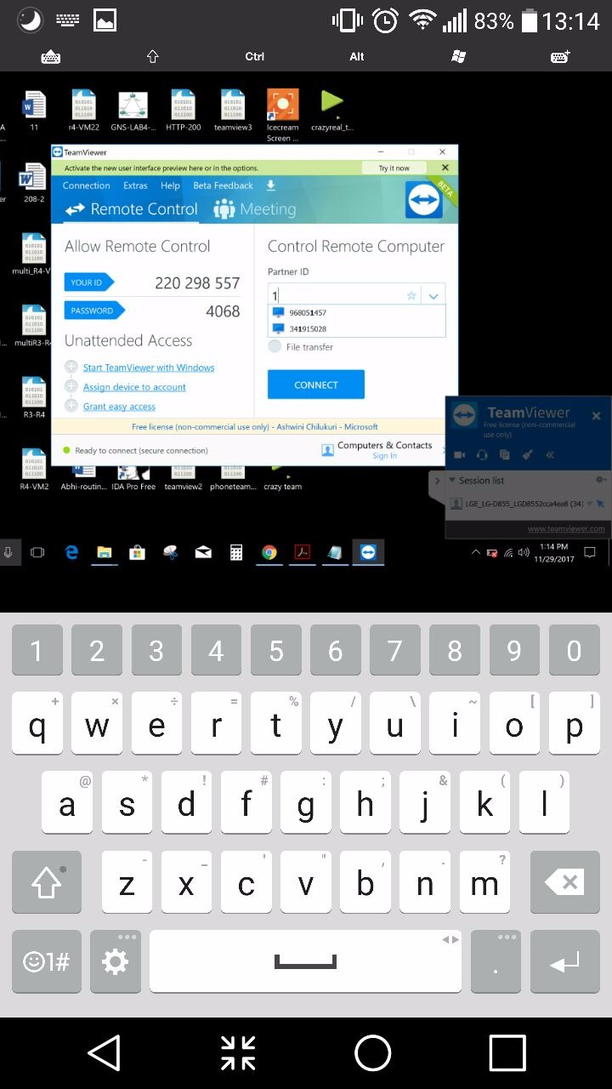

* 1. Windows 10 PC having remote access over Android phone

In this test case we tried to analyze the security features when a PC gains control over an android phone via TeamViewer. On phone we had to download quick support and more add-ons to give PC remote control over it. **We noticed a security issue where the PC doesn’t need to know the phone’s TeamViewer passcode.** Just by clicking accept on the phone, the PC was able to have complete access over it.

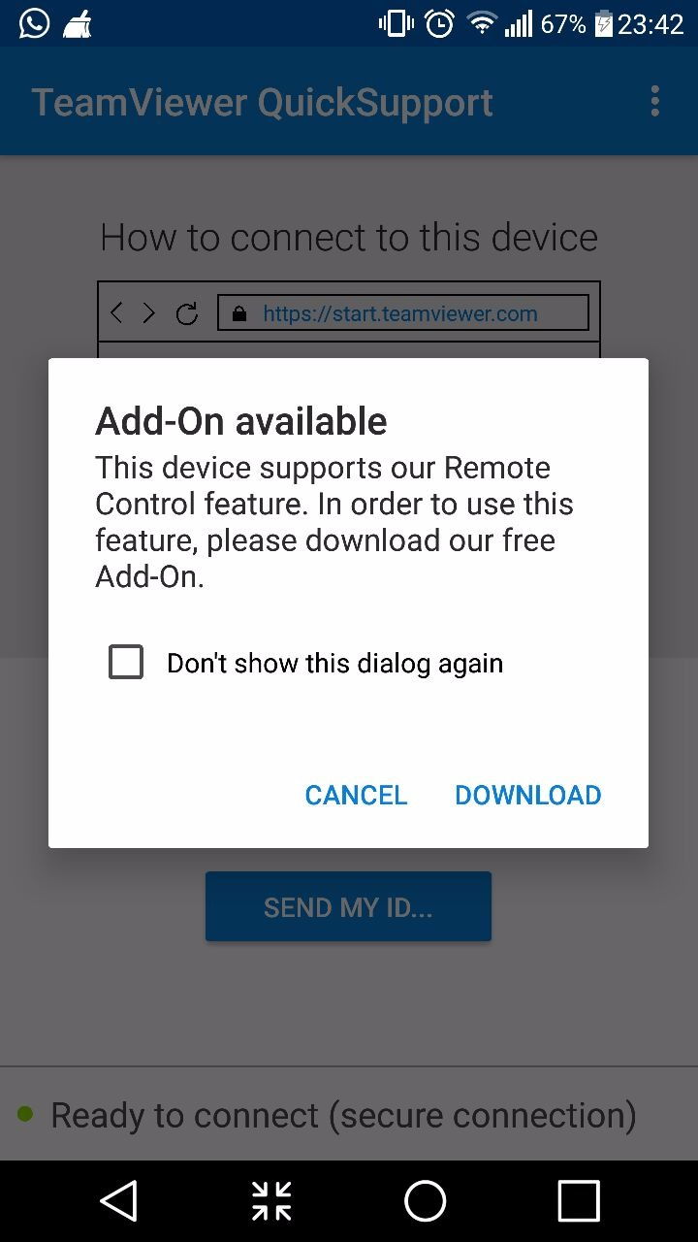

By installing Quick Support, we can establish a chat session. But for giving phone access to the PC, we nee to install suggested add-ons.

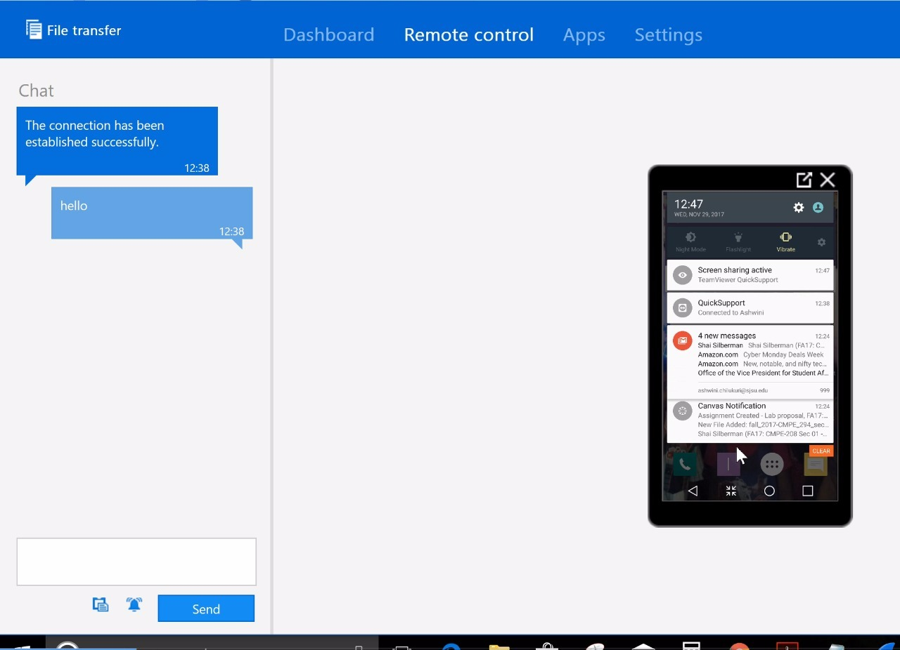

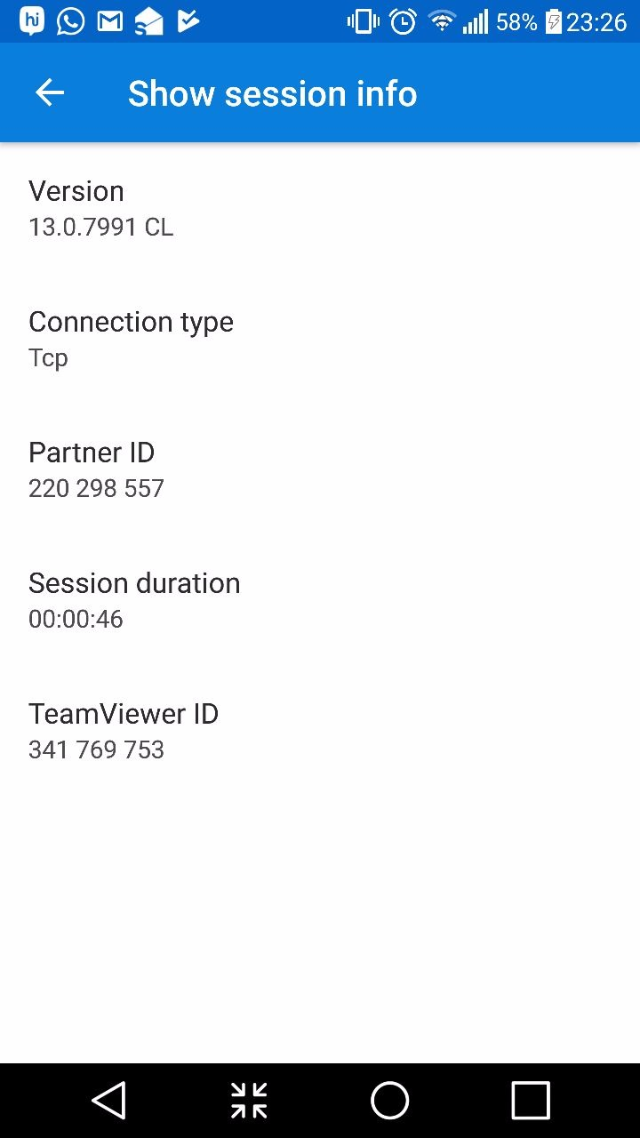

After installing the add-ons, the PC can gain complete access over the phone **without any passcode authentication.** This feature can be used by hackers or anyone trying to gain unethical access to someone’s phone. In our view, it can be considered as a **security bug**.

* 1. Connect 2 windows laptops simultaneously to one another

In this test case, client 1 connected to client 2 which in turn connected back to client 1. We could observe an infinite loop of connections being established. The screenshot of the same can be observed below.

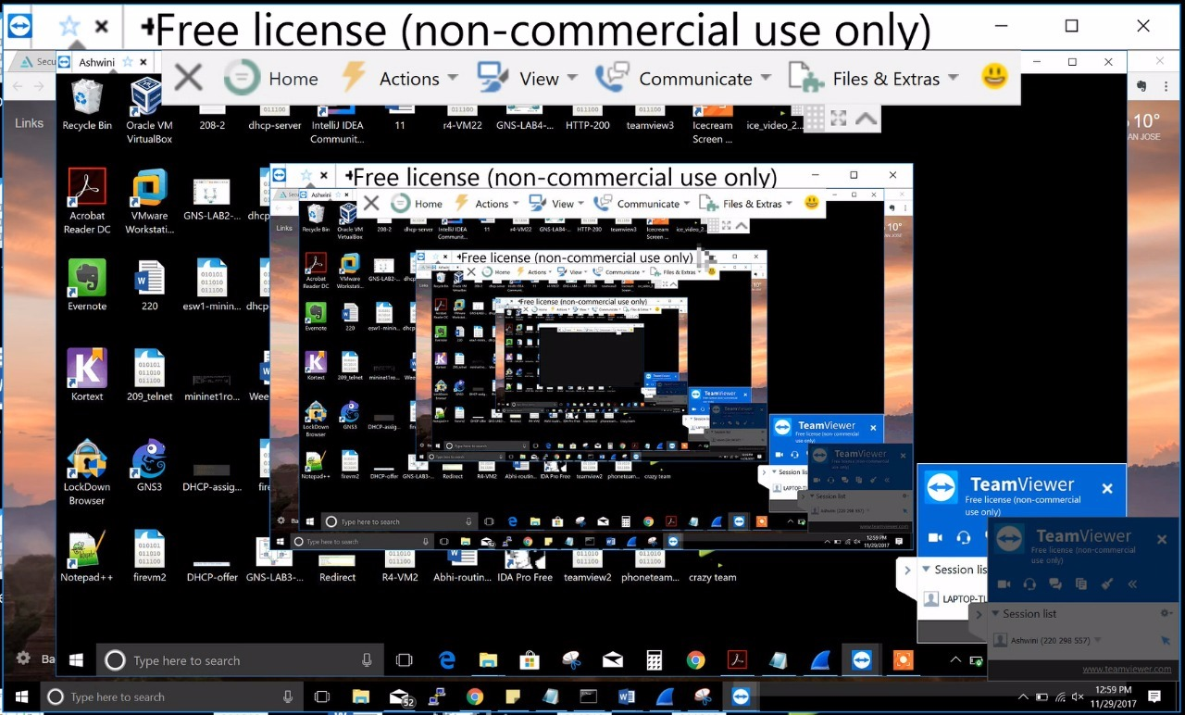

# **Findings**

1. TeamViewer is a decent desktop remote access application which can be used over various platforms to connect peers to each other.
2. We observed TeamViewer uses https and Transport Layer Security for “integrity, authentication and confidentiality”.
3. It uses RSA 2048(public-private key) for public key exchanges and AES 256 (symmetric) for desktop connection and communication
4. The master server that connects with the client provides its certificate via SHA256 algorithm.
5. Connection between PCs as peers seems to be secure enough, while connection between PC and phone does not even ask for a passcode. This feature can be easily exploited by hackers.
6. By default, a 4-digit passcode is used by those who install it. This passcode remains unchanged until the application is manually logged out. This feature can also be exploited by hackers.
7. If brute force is applied on the passcode, TeamViewer increases the connection establishment time exponentially. This timer can be reset only when the right pass code is entered.
8. We were able to capture the TeamViewer peers’ handshake process in all our test cases and analyze the protocols that are used beneath.

# **References**

TeamViewer Security Statement. *TeamViewer*, *Inc*., Retrieved on 20th November, 2017 from

[http://downloadus1.teamviewer.com/docs/en/TeamViewer-Security-Statement- en.pdf](http://downloadus1.teamviewer.com/docs/en/TeamViewer-Security-Statement-%20%20%20en.pdf)

Technical View of TeamViewer Account Security. *TeamViewer, Inc.,* Retrieved on 20th November, 2017 from

<https://community.teamviewer.com/t5/Knowledge-Base/A-technical-view-on-the-TeamViewer-account-security/ta-p/4714>

Secure Remote Password Protocol. *Wikimedia Foundation, Inc.,* Retrieved on 20th November, 2017 from

<https://en.wikipedia.org/wiki/Secure_Remote_Password_protocol>

Secure Remote Password Protocol Analysis. *Stanford, Edu.,* Retrieved on 20th November, 2017 from

<http://srp.stanford.edu/analysis.html>

Wireshark. *Wireshark, Org.,* Retrieved on 20th November 2017 from

<https://wiki.wireshark.org/SSL>

Password Authenticated Key Agreement. . *Wikimedia Foundation, Inc.,* Retrieved on 20th November, 2017 from

<https://en.wikipedia.org/wiki/Password-authenticated_key_agreement>